**LIT ASSIGNMENT DAY 14**

NAME: Rachepalli Madhavi

EMPLOYEE ID: 46255250

Batch Name: SAP ABAP - 25

CDS-Assignment 1 – Create a Simple CDS view with Date Functions in ABAP CDS Views

Tables involved – VBAK

Created CDS View:

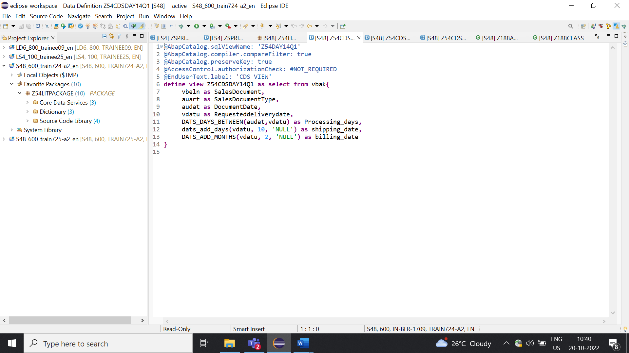

Output:

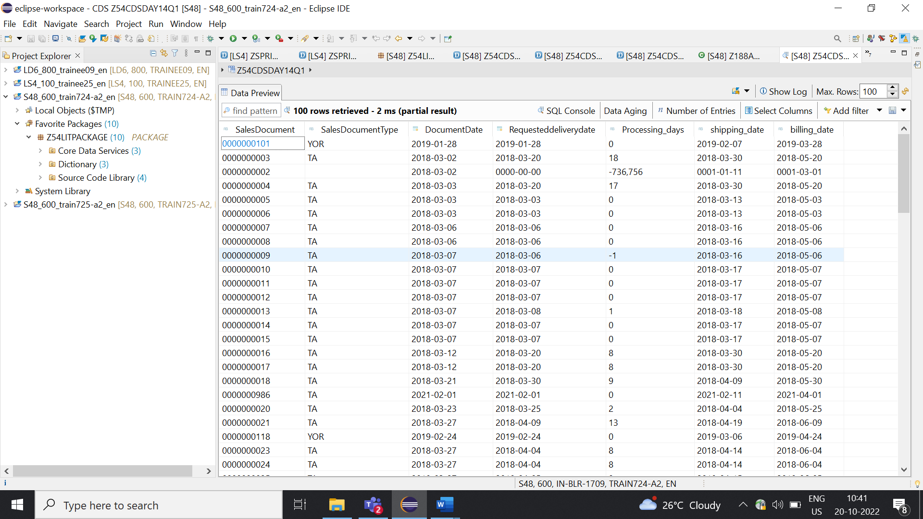

CDS-Assignment 2 – Create a Simple CDS view with String Functions in ABAP CDS Views

Tables involved – KNA1

Created CDS View with String Functions:

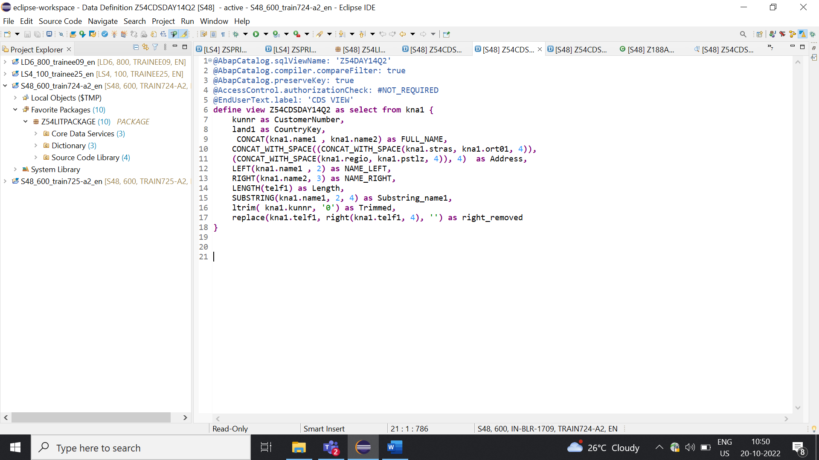

Output:

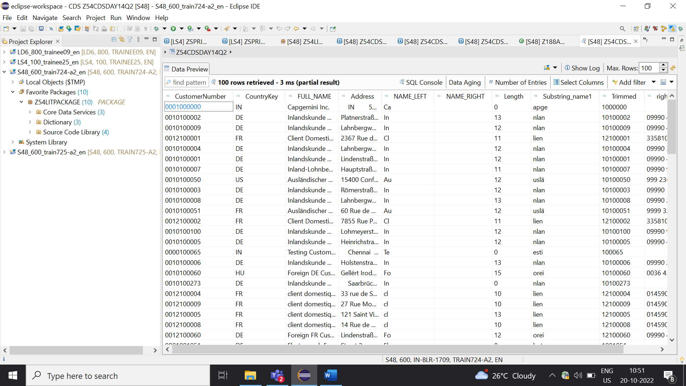

CDS-Assignment 3 – Create a Simple CDS view with Parameters

* Create a CDS view with GL currency (PSWSL) as parameter and get the entries form BSEG

Tables involved – BSEG

Created CDS View with Parameters:

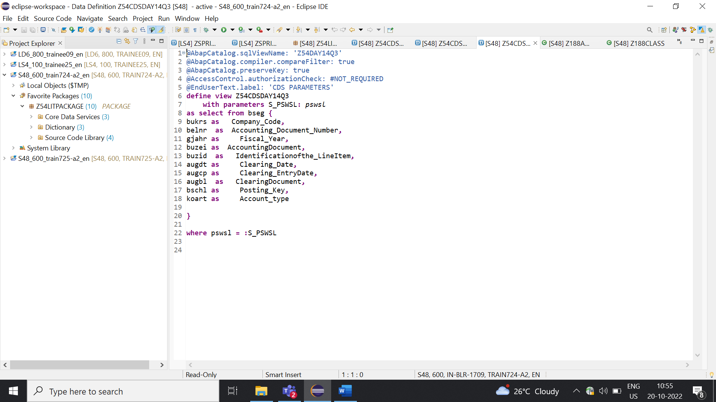

Output:

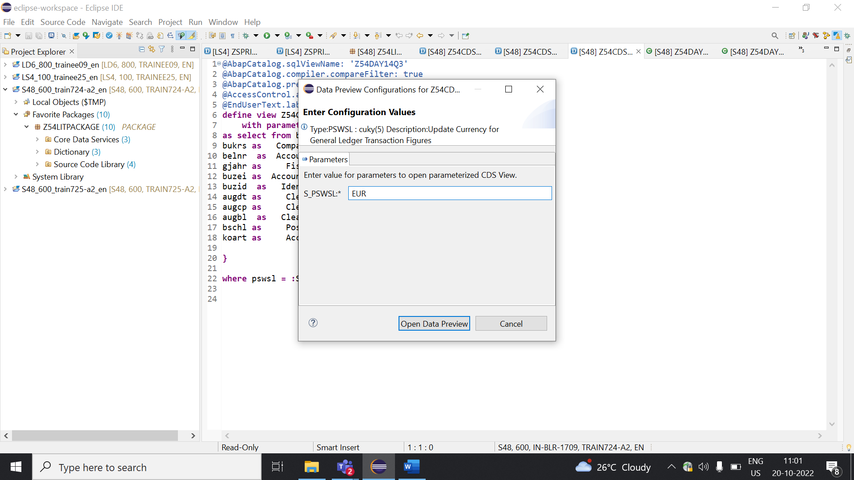

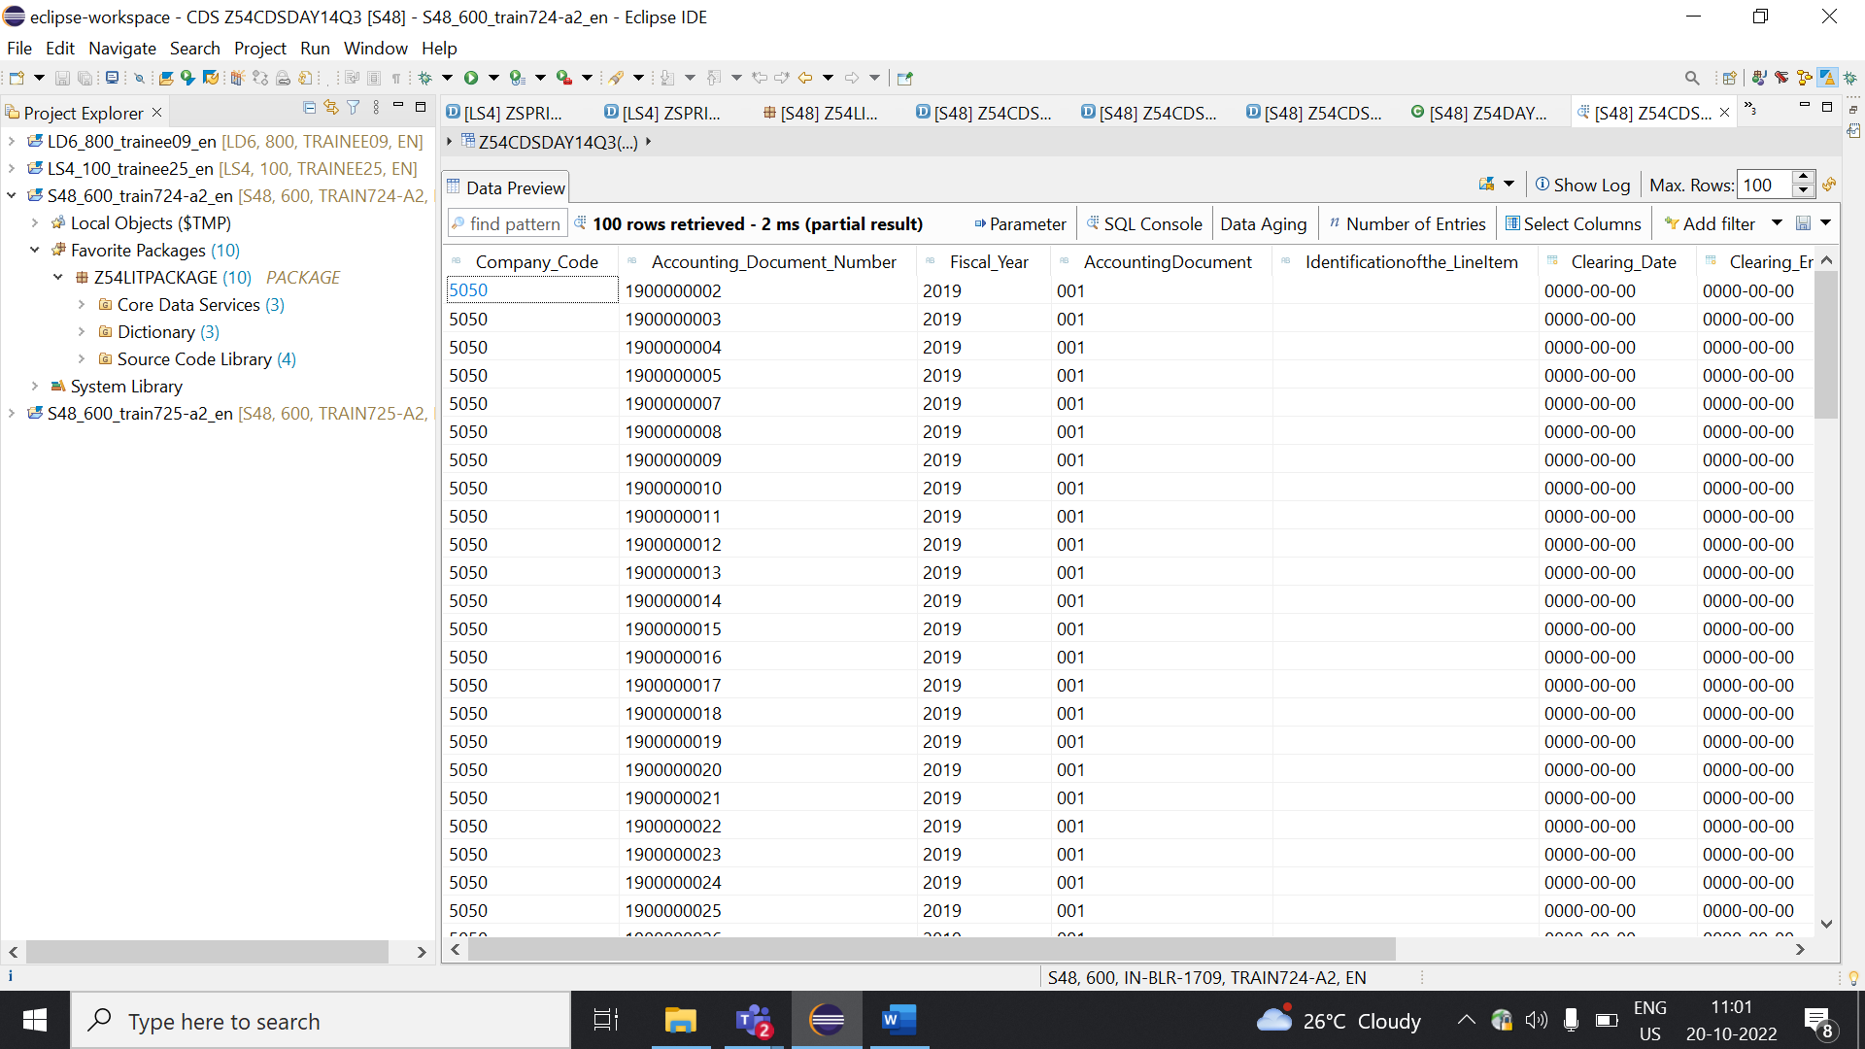

AMDP-Assignment 1 – Procedures - create a basic procedure to fetch data with scalar variable

Scenario –

* Print Sales Order number, Material Number, Quantity from VBAP table using scaler variable

Tables involved – VBAP

Created Class:

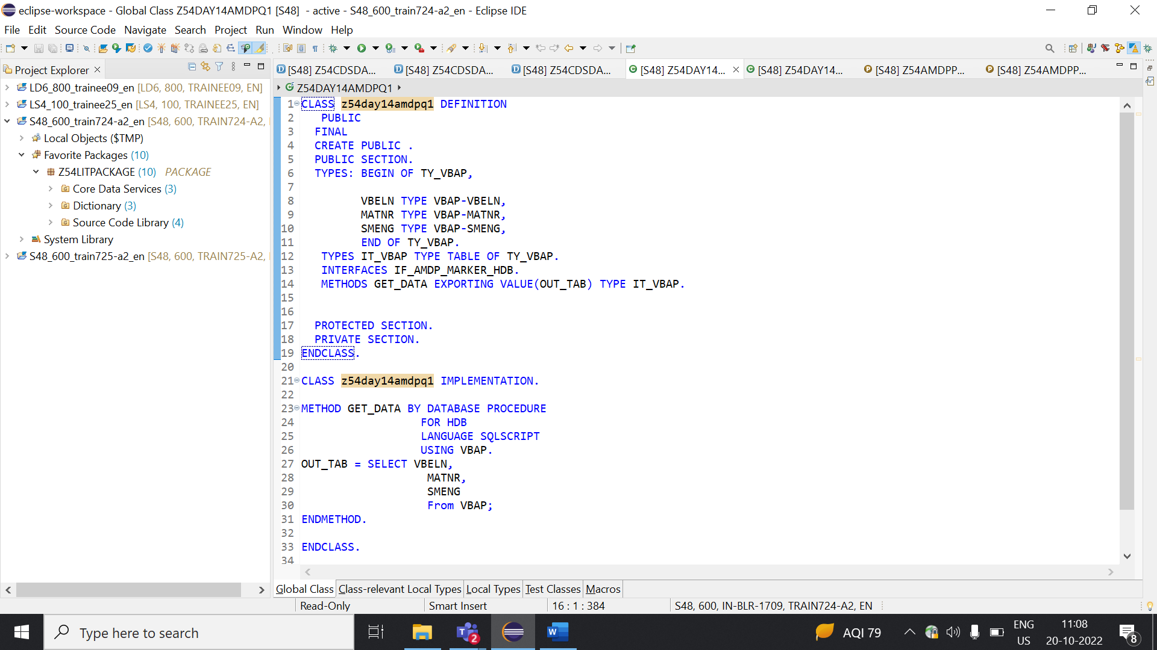

Created Program:

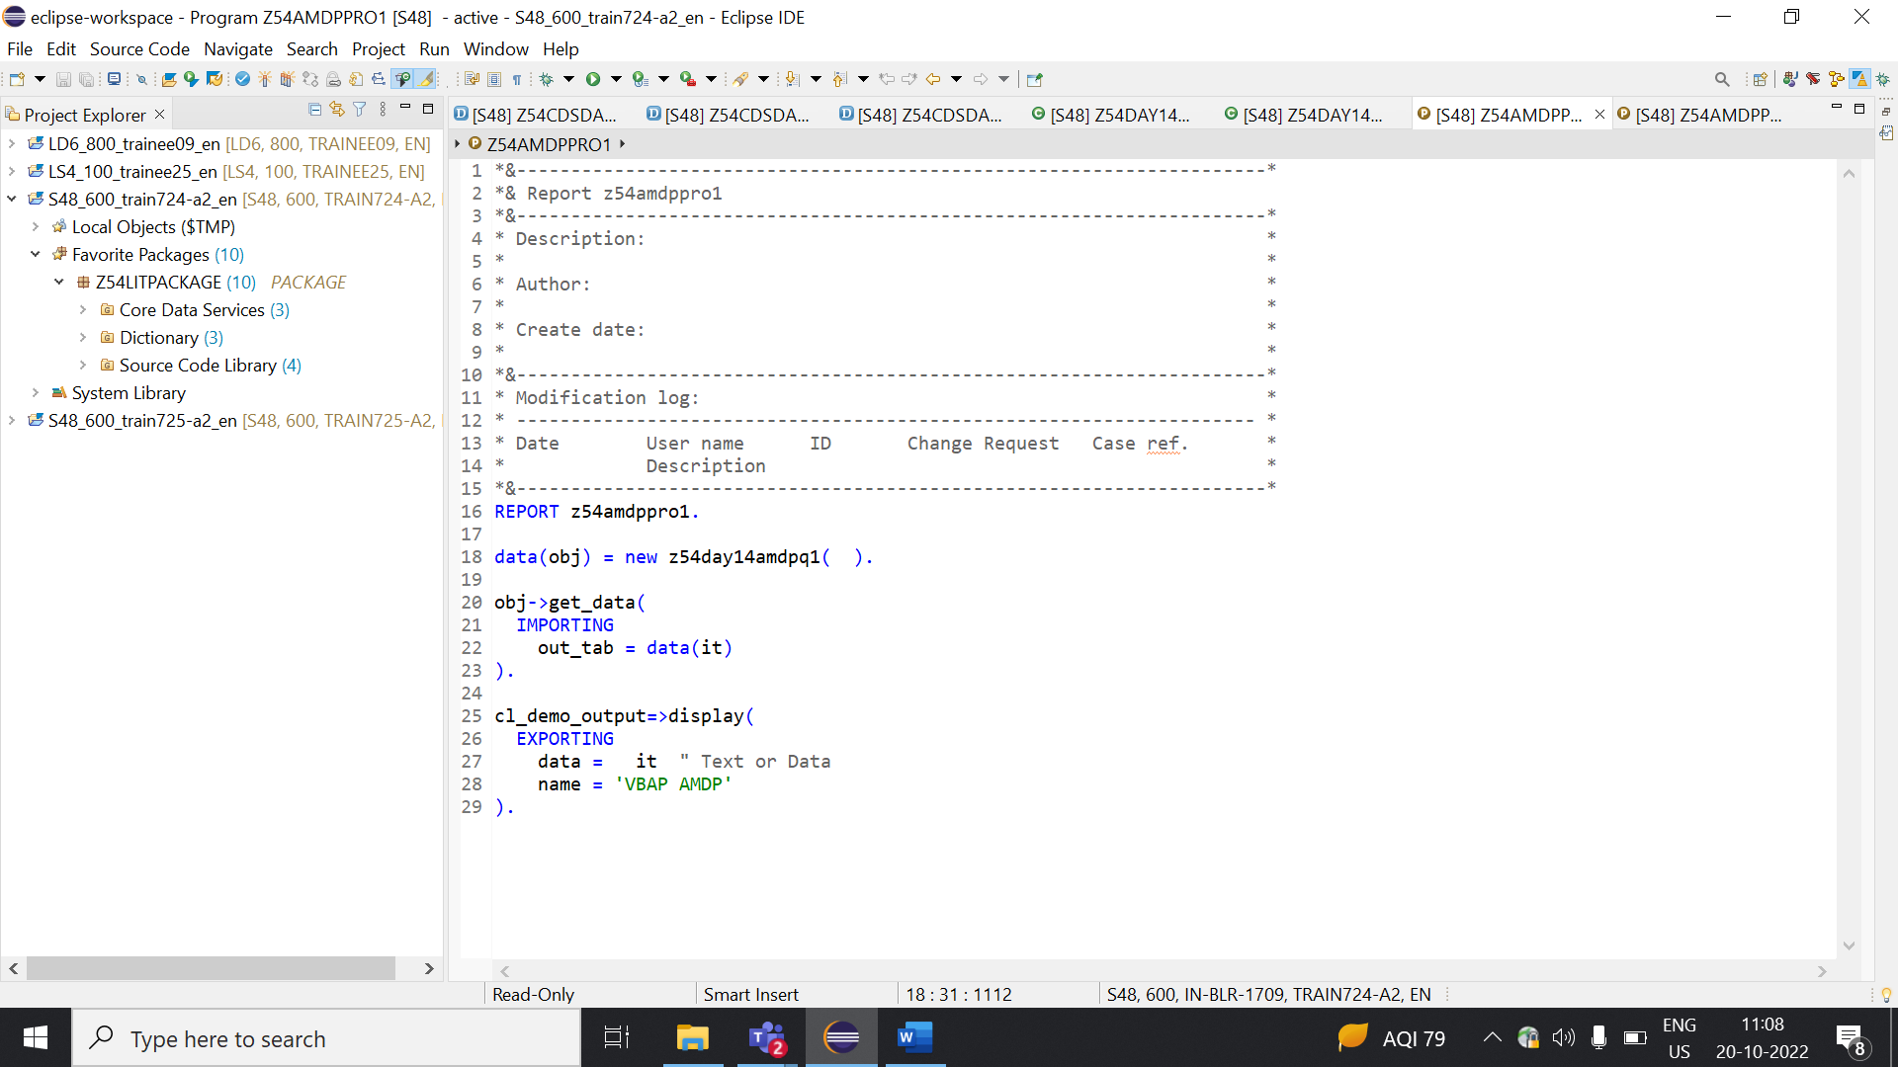

Output:

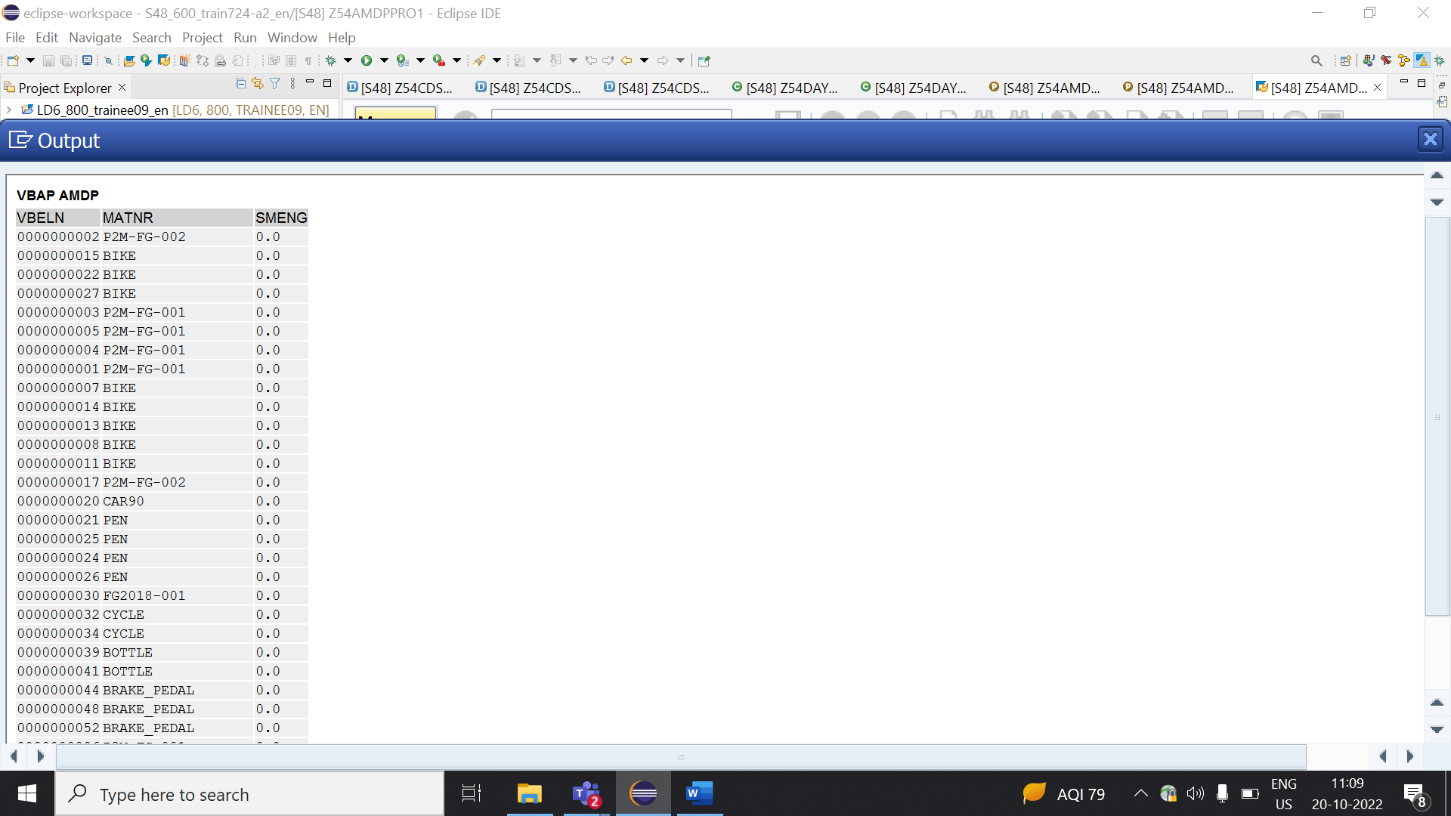

AMDP-Assignment 2 – Procedures - create a basic procedure with Table

Scenario –

* Select VBELN, VKORG, MATNR, MENGE from VBAK and VBAP and display the data using table based on material (MATNR).
* MATNR will be input field
* Do inner join

Tables involved – VBAK, VBAP

Created Class:

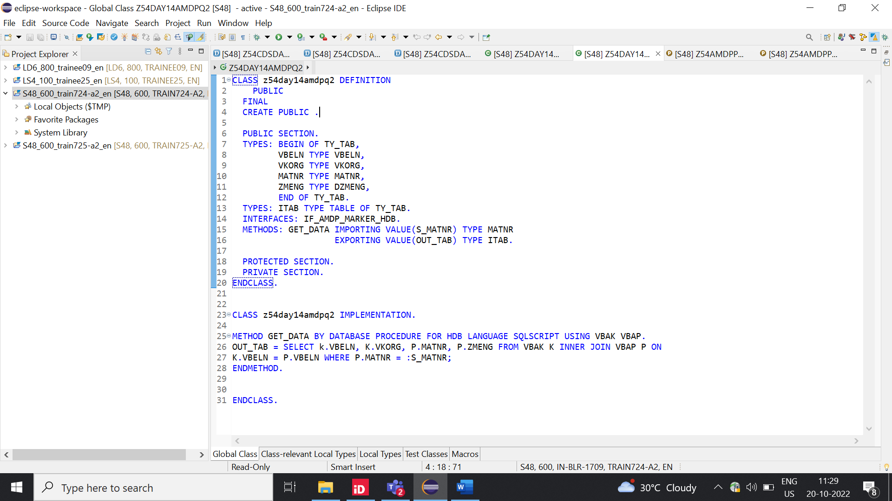

Created Program:

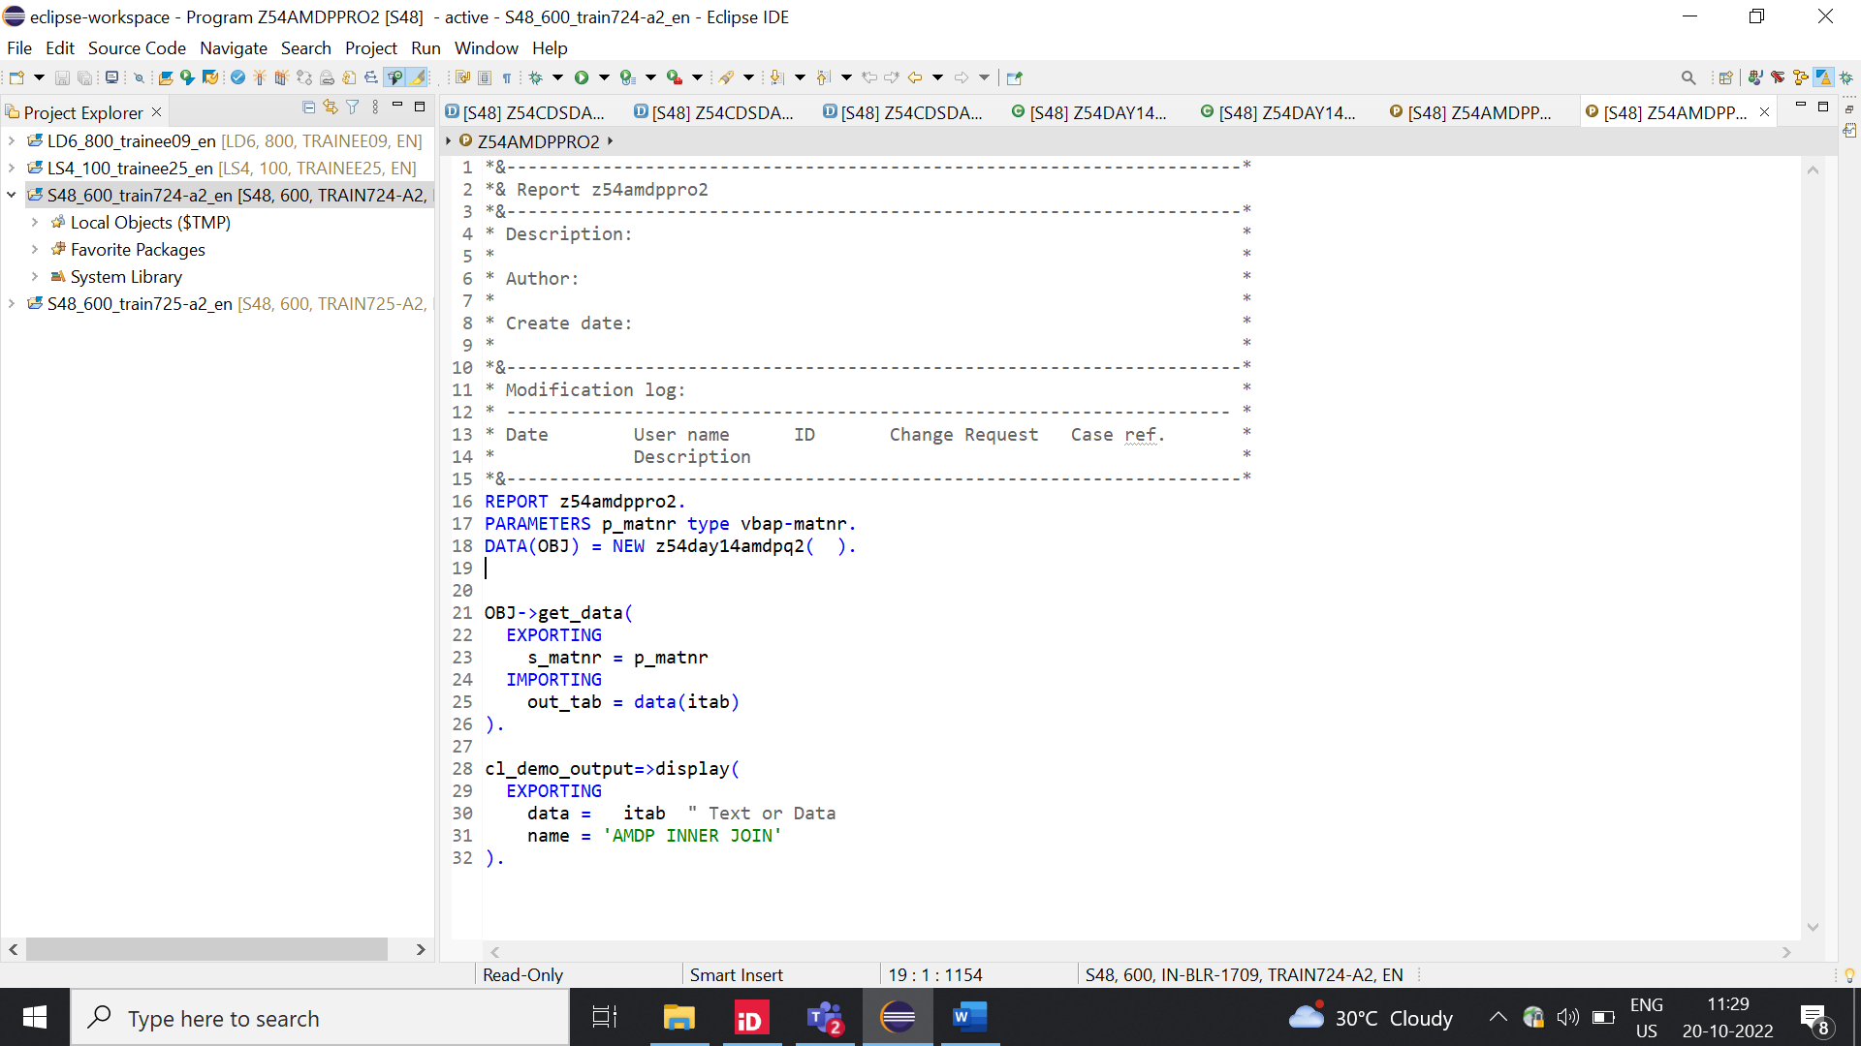

Output:

